

**How to Add Two or More Folders into one repository**

**This Was something that I really wanted to do with my projects at the very beginning where this may not be suitable in development process. Since we usually create two separate repositories for both front end and back end. But if we want to keep our final project at one particular repository this method will suits more. So we can find both the front end and back end in one particular repository. But I recommend you to create two separate repositories when you are at development period. There is no source in the internet to set many folders to one particular repository. Hope this blog will help you.**

**I will demonstrate it using an example to get more clearer.**

**Here (in picture 1) is a folder called The_End _Code_Infinity and inside the folder I have both my front end and back end projects. What I will demonstrate is that how both of these folders are pushed into one repository. (Like in picture 2)**

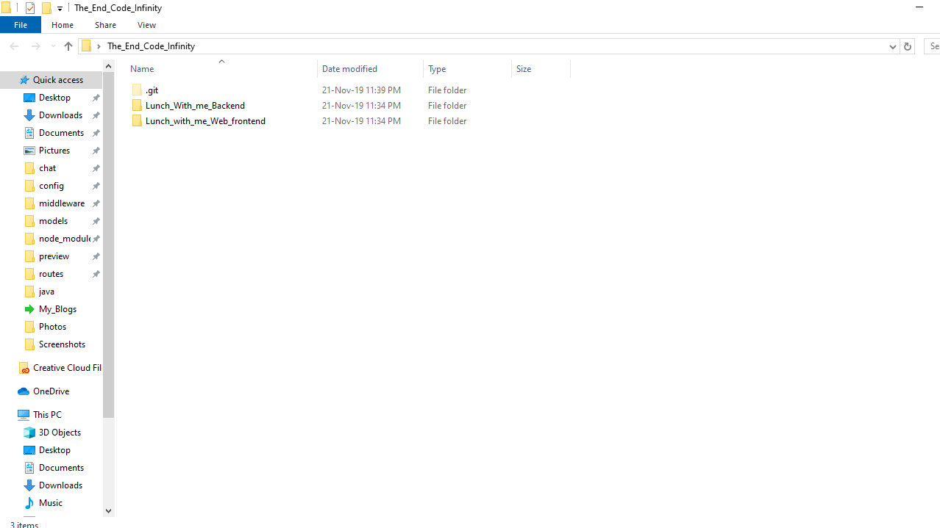

Picture 1

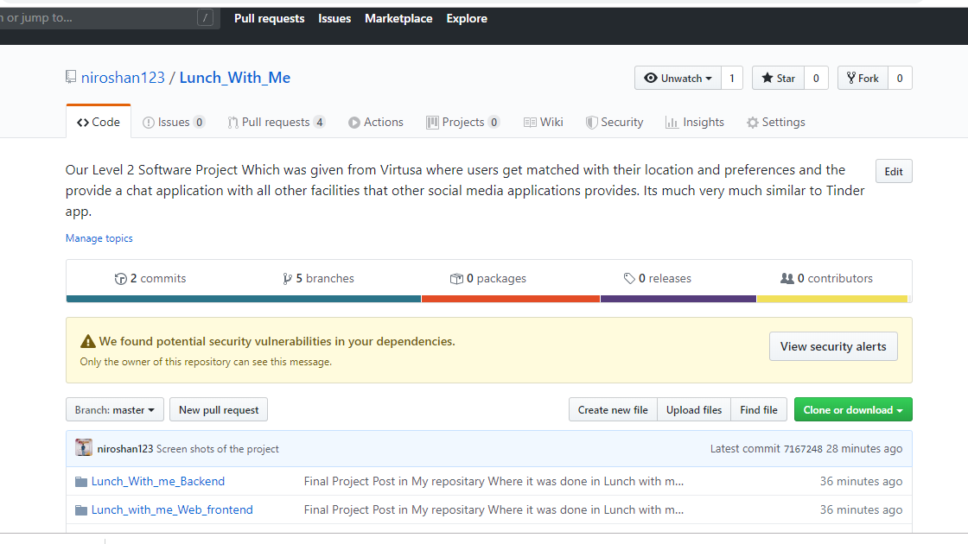

Picture 2

In picture 2 we have created a repository called Lunch_With_Me and I have added both the folders in to this repository. These are the steps that you should follow.

1. Create a repository in github like you create as usually.
2. Next go inside the folder that you find your main folders that you need to push. In picture 1 you have to go to The_End _Code_Infinity folder and then right click on anywhere of that folder and select git bash here and follow below steps in git bash
3. git init
4. git add Lunch_With_me_Backend Lunch_with_me_Web_frontend(these are your folders inside The_End _Code_Infinity folder).
5. git commit -m "Final Project Post in My repositary Where it was done in Lunch with me Team Repository" => (any commit message)
6. git remote add origin your repository link that you may copy from the repository you created
7. git push -u origin master
8. git push origin master
9. And now you are done☺

Niroshan Ratnayake(The Author)

